**Module 3: Critical Thinking Assignment**

Brady Chin

Colorado State University Global

CSC500-1: Principles of Programming

Dr. Steven Evans

June 2nd, 2024

**Module 3: Critical Thinking Assignment**

This weeks critical thinking assignment consists of two parts. In the first part, we are tasked with creating a program that prompts the user to enter the cost of a meal then calculates the tip and tax percentage. Each amount is then displayed. The second part prompts the user to enter the current time and a wait time. The program will then output a time on a 24-hour clock that the alarm will be set for.

**Part 1**

I found part 1 to be pretty straight forward. By simply taking user input, I was able to calculate the tip and tax percentage to determine the final amount. One incident that I did come across was converting the user input to a type that can be used for calculations. At first I tried simply used *float* but that comes with rounding issues. By referring to LinkedIn Learning from Module 2.1 Python Variables (Colorado State University Global), I imported the Decimal module, a module that is best used for banking situations where rounding is critical. I was then able to correctly calculate the tip, tax, and total amounts.

After completing this part, I thought that it would be a great function that could be incorporated into larger projects. I haven’t looked into the finer details of our portfolio project but that could be a great place to incorporate this function.

**Part 2**

When I first started part 2, I was a bit taken back on the difficulty. It seems like a simple problem but when you sit down and start working on it, you realize all the places for error. I then wrote out the logic to better understand the process flow and was able to create a rough draft of this project.

After I got the program functioning properly, I realized that it is pretty unstable. If the user does not enter exactly the right information, the program will return an error. This made me go deep into error handing ([python.org](http://python.org)).

While I was working on the error handling, I thought that I was probably diving into topics and content that is beyond what we have learning so far in this course. I didn’t mind too much since it is good practice and that I can refer back to this project in the future.

After I handled the error that I encountered, I added the same logic to part 1 of this critical thinking. Then, I looked over my code and thought that I may have over engineered what originally seemed like a simple problem. I would appreciate any feedback that you can give on areas that I could exclude or improve on.

Finally, while creating this program, I thought of ways that this could be taken a step or two further. Instead of just handling time by the hour, we could also handle minutes and seconds. Furthermore, we could ask the user what day of the week it is then calculate what day of the week the alarm will go off if the wait time is longer than 24 hours.

**Screenshots**

Part 1: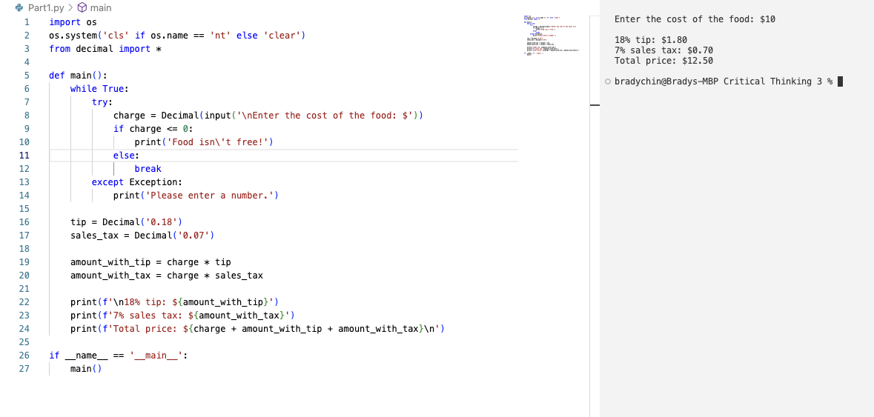

Part 2: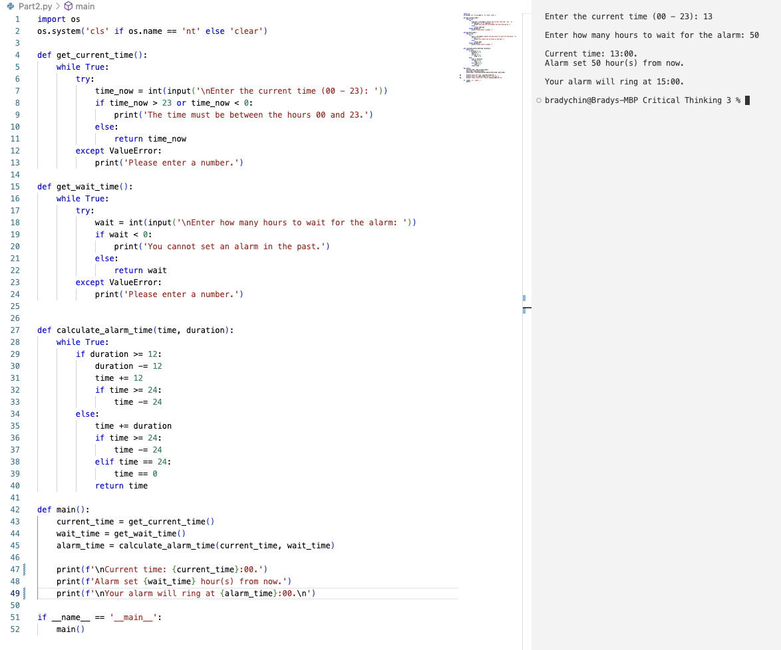

**GitHub Repository and Pseudocode**

GitHub Repository: [LINK](https://github.com/bradychin/principles-of-programming/tree/3e554cb7fa3441add00ed92d78b9ce383ccf5479/Critical%20Thinking%20Assignments/Critical%20Thinking%203)

Part 1 Pseudocode: [LINK](https://github.com/bradychin/principles-of-programming/blob/3e554cb7fa3441add00ed92d78b9ce383ccf5479/Critical%20Thinking%20Assignments/Critical%20Thinking%203/Part1Pseudocode.txt)

Part 2 Pseudocode: [LINK](https://github.com/bradychin/principles-of-programming/blob/3e554cb7fa3441add00ed92d78b9ce383ccf5479/Critical%20Thinking%20Assignments/Critical%20Thinking%203/Part2Pseudocode.txt)

**References**

Colorado State University Global (2024, May 13th) *2.1 Python Variables.*

<https://csuglobal.instructure.com/courses/93533/pages/2-dot-1-python-variables?module_item_id=4786646>

Python Software Foundation (2024, May 29th) *8. Errors and Exceptions*

<https://docs.python.org/3/tutorial/errors.html>